**VERSION HISTORY**

|  |  |  |  |  |
| --- | --- | --- | --- | --- |
| **REV.** | **VERSION DETAIL/S** | **AUTHORED BY:** | **APPROVED BY:** | **DATE APPROVED** |
| 1.0 | Agreed and SIGNED OFF Guidelines | Indra | Globe ISG | 12/20/2019 |
| 1.1 | Added annexes and updated questions # 4,7,8 and 9 | Indra |  |  |
|  |  |  |  |  |
|  |  |  |  |  |
|  |  |  |  |  |

Contents

Objective 3

IPA Questionnaire 3

ANNEX A: Input Data Types 6

ANNEX B: Input Data Count 8

**Initial Process Assessment (IPA)**

# Objective

This questionnaire will describe the process that will be helpful to understand the different aspects of the process. These are the key information needed in order to assess a process for RPA.

# IPA Questionnaire

**Let’s know more about your selected process.**

1. What is the name of your nominated RPA process?
2. Give a brief overview of the process.
3. What applications/platforms are being used by the agent in this process?
   1. Gmail
   2. MS Excel
   3. MS Word
   4. Google Sheets
   5. Google Docs
   6. SMS
   7. Messaging Apps
   8. myBSS CRM
   9. Databases
   10. Others (please specify)
4. How many times does the “screen” switch in executing the whole process? *(Count of screen changes across the whole process.)*

a. 0-10

b. 11-20

c. 21-30

d. More than 30

1. Does the agent need remote access (e.g. Citrix) to execute this process?
   1. Yes
   2. No
2. Does any of the steps in executing this process have RPA involved already currently?
   1. Yes
   2. No

**What kind of information are you handling in this process?**

1. How many input data, regardless if it’s standard or free text, does the process have? Refer to Annex A and B for samples *(Answer must be a number only.)*
2. Are there any free text (structured/unstructured) information involved in this process? If the answer is yes, please indicate if it’s structured, unstructured or both. *(i.e. Yes – Structured)*
   1. Yes
   2. No
3. In relation to item 8, if the answer is yes, how many input data are categorized as “free texts”? *(Answer must be a number only and if possible, categorize if it’s structured or unstructured.)*
4. Are there any scanned documents/images involved in order for the agent to execute this process?
   1. Yes
   2. No
5. What is the expected output of this process? (Pick all applicable.)
   1. Generate e-mail
   2. Generate document
   3. Send SMS
   4. Create or update an entry into the system
   5. Others (please specify) _______________

**Let’s know more about what you do.**

1. How long has this process existed?
   1. Less than 1 year
   2. 1 year or more
2. What is the operating hours for the execution of this process?
   1. 8AM-5PM, Mon-Fri (8x5)
   2. 12AM-12AM, Mon-Sun (24x7)
   3. Others (please specify)
3. How often is this process executed?
   1. Daily
   2. Weekly
   3. Every 2 weeks
   4. Every 3 weeks
   5. Monthly
   6. Others (e.g. If the operating hours for the process is 8x5, indicate 5 times a week.)
4. How many total man hours is needed to execute this process? (e.g. Indicate headcount and respective dedication, in man hours spent for the process)
5. What’s the average amount of transaction requests coming in for this process? (i.e. Based on the answer in item 13)
6. What’s the highest amount of transaction requests coming in for this process? (i.e. Based on the answer in item 13)
7. What is the average handling duration per transaction/item for the execution of this process? (i.e. In minutes)
8. What is the Service Level Agreement (SLA) per transaction/item for the execution of this process? (i.e. in minutes)
9. Is the business process or system expected to change or be changed within the next 6 months?
   1. Yes
   2. No

**What difficulties do you encounter?**

1. What errors do the agent encounter when executing this process?
   1. System crashes
   2. Network failure
   3. Pop-ups
   4. Incorrect data
   5. Others (please specify)
   6. None
2. How often does the agent encounter these errors when executing this process?
   1. Daily
   2. Weekly
   3. Every 2 weeks
   4. Every 3 weeks
   5. Monthly
   6. Others (please specify)
3. How many times does the agent encounter these errors? (e.g. twice daily, once weekly, etc.)

# ANNEX A: Input Data Types

**SAMPLES OF INPUT DATA – Standard and Free Text**

**Standard –** Inputs are standard if the content is positioned in the same place even if the input types are different. E.g. in an invoice, the position of the details (invoice number, date, amount, name etc.) are always fixed, regardless of the input type (PDF, Word etc.)

1. Standard Input – Data is located at a specific location and does not need logic to locate.

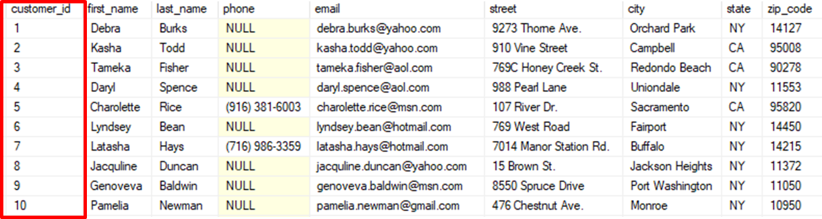

*Getting data from the first column will always result in getting the customer ID*

**Free Text –** Inputs are considered as nonstandard when the position of the content varies from one input type to another

1. Structured Free Text – Data is located at a specific location but needs simple logic to locate.

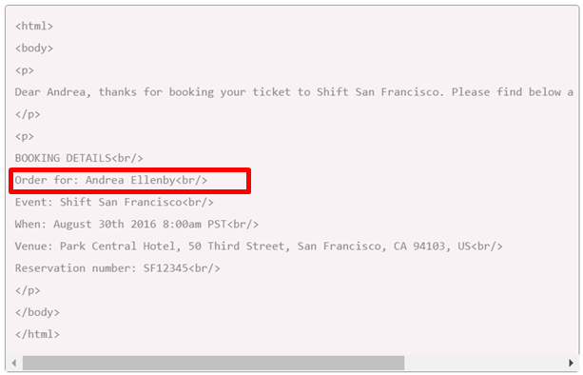

*Getting the customer name from the email will need logic to look for the text after the “Order for: “*

1. Unstructured Free Text – Data is not located at a specific location and will need complex logic to locate.

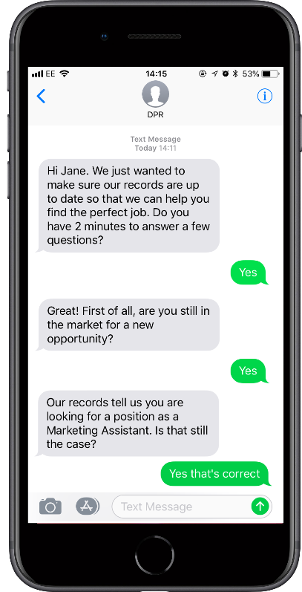

**Pictures –** Data is in an image format and will need an image recognition software to read.

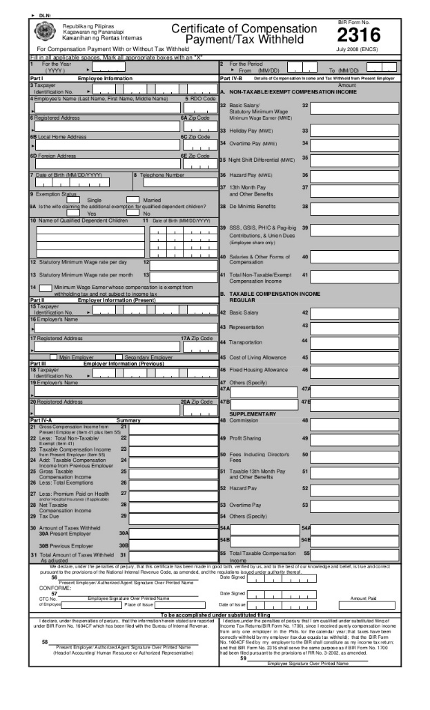

*This will need an image recognition software in order to import the data from this picture.*

# ANNEX B: Input Data Count

Input data is data from a source that needs processing to generate an output.

In the sample below, each cell can be considered as an input data. For example, encoding details of customer ID#5 gives you 8 input data *(first name, last name, phone, email, street, city, state and zip code)*.

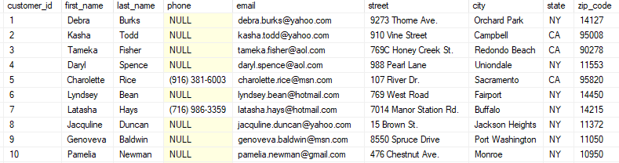

Counting input data in images is also the same.

